Proposition de correction

Exercice 1

Q1
description(id_description (int), resume(char), duree (int), #id_emission (int))

Q2.a
Le système d’enseignement supérieur français est-il juste et efficace, 2022
Trois innovations pour la croissance future (1/3) : La révolution blockchain., 2021

Q2.b
SELECT theme
FROM podcast
WHERE annee = 2019

Q2.c
SELECT theme, annee
FROM podcast
ORDER BY annee

Q3.a
Affiche tous les thèmes distincts de la relation podcast.

Q3.b
DELETE
FROM podcast
WHERE id_podcast = 40

Q4.a
UPDATE emission
SET animateur = ‘Emmanuel L.’
WHERE id_emission = 10175

Q4.b
INSERT INTO emission
VALUES(12850, ‘Hashtag’, ‘France Inter’, ‘Mathieu V.’)

Q5
SELECT podcast.theme, emission.nom, description.resume
FROM podcast, emission, description
WHERE description.duree < 5
AND emission.id_emission = description.id_emission
AND podcast.id_emission = emission.id_emission

Exercice 2

Q1.a
101001000.10110010.00000010.00001101

Q1.b
24 premiers bits à 1 (3 octets) → 164.178.2.0/24

Q2
A → D → F → G
A → D → E → G
A → B → E → G

Q3.a
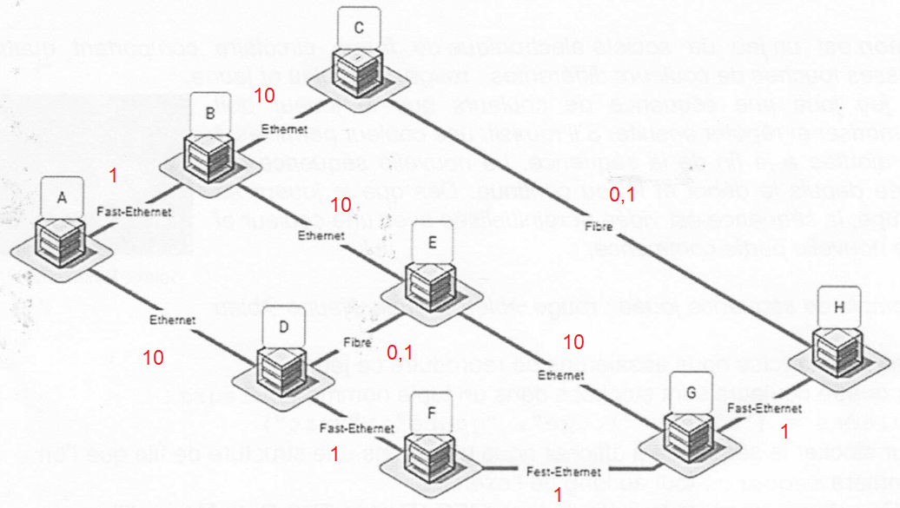

Q3.b
A → D → F → G

Q3.c
A → B → C → H → G

Exercice 3

Q1
def ajout(f) :
couleurs = ("bleu", "rouge", "jaune", "vert")
indice = randint(0, 3)
enfiler(f, couleurs[indice])
return f

Q2
def vider(sequence)
while not est_vide(sequence) :
defiler(sequence)

Q3
def affich_seq(sequence) :
stock = creer_file_vide()
ajout(sequence)
while not est_vide(sequence) :
c = defiler(sequence)
affichage(c)
time.sleep(0.5)
enfiler(stock, c)
while not est_vide(stock):
enfiler(sequence, defiler(stock))

Q4.a
def tour_de_jeu(sequence) :
affiche_seq(sequence)
stock = creer_file_vide()
while not est_vide(sequence) :
c_joueur = saisie_joueur()
c_seq = defiler(sequence)
if c_joueur == c_seq :
enfiler(stock, c_seq)
else :
vider(sequence)
while not est_vide(stock) :
enfiler(sequence, defiler(stock))

Q4.b
def tour_de_jeu(sequence) :
while True :
taille_seq = taille(sequence)

affiche_seq(sequence)
stock = creer_file_vide()
while not est_vide(sequence) :
c_joueur = saisie_joueur()
c_seq = defiler(sequence)
if c_joueur == c_seq :
enfiler(stock, c_seq)
else :
vider(sequence)

if taille(stock) == taille_seq :
while not est_vide(stock) :
enfiler(sequence, defiler(stock))

ajout(sequence)

